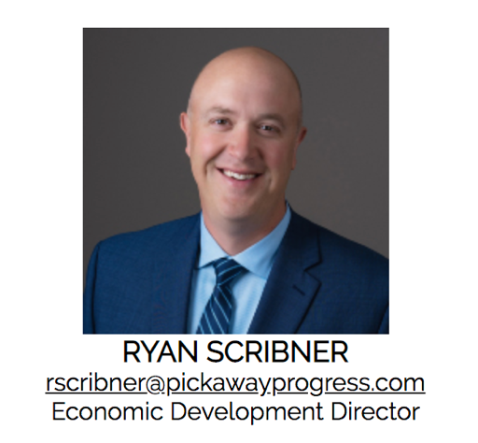
Ryan Scribner is the Economic Development Director for the Pickaway Progress Partnership (P3), the economic development agency for Pickaway County and its municipalities. In this role Ryan facilitates and manages discussions among local government officials, developers and stakeholders to construct joint development agreements, advance creative solutions to finance public infrastructure, and develop incentives to attract and retain industry. Ryan is charged with marketing and selling the benefits of locating and investing in Pickaway County to targeted companies, developers, site selectors and consultants. He also works with existing industry to identify federal, state and local government programs that can assist in growing their business in Pickaway County.
Before coming to P3, Ryan served for three years as Pickaway County Administrator. As the chief administrative officer of the County he developed budgets, managed capital improvement projects, and directed a variety of county departments and agencies. He began his professional career as a legislative aide in the Ohio House of Representatives. He then spent four years as Legislative Liaison for the Ohio Board of Regents. Ryan lives in Pickaway County with his wife and two sons.

